SQL :

SQL is a database language which is introduced by ibm to communicate with database.

It is not case sensitive. Which means you can give uppercase case / lower case / combination of both.

Industry recommended : write the SQL queries in the upper case.

**Types of SQL Languages:**

We have 5 sub-languages are there:

**1. Data Definition Language (DDL):**

1. Create
2. Alter
3. Rename
4. Truncate
5. Drop

Latest Features in DDL:

1. Recyclebin
2. Flashback
3. Purge

**2. Data Manipulation Language (DML):**

1. Insert
2. Update
3. Delete

Latest Commands in DML:

1. Insert all
2. Merge

**3. Data Query / Retrieval Language (DQL / DRL):**

1. Select

**4. Transaction Control Language (TCL):**

1. Commit
2. Rollback
3. Savepoint

**5. Data Control Language (DCL):**

1. Grant
2. Revoke

Data types

Data types used to represent the nature of data that can be stored in the database table. For example

if we want to store string type data in a particular column, then we have to declare string data type for this column.

Oracle data types are classified into 6 categories

1. Numeric data types
2. String / character data types
3. Long data types
4. Date data types
5. Raw and long raw data types
6. Lob data types (large objects data types)

**1) Numeric Datatypes in Oracle:**

They are categorized into two types.

1. Int
2. Number(P, S)

**INT:**

Storing integer format values only.

Sno int —————–> Sno Number(38)

**Note:** When we use INT datatype on the column at the time of table creation then internally oracle server will convert it into “number” datatype with a maximum size is 38 digits.

**Number(P, S):**

This data type is basically used for storing both integer & float format values. Here this datatype is having following two arguments i.e. precision(P), scale(S).

1. When we use —-> Number(P)——–> Sore integer values only
2. When we use —-> Number(P, S) —-> Store float values only

**Precision(p):**

counting all digits including left & right sides digits of a decimal point.  
Example: 25.12 => Precision = 4  
Example: 856.45 => Precision = 5  
Example: 9999.99 => Precision = 6

**Scale(s):**

Counting only right digits of a float expression.  
Example: 25.12  
Scale = 2  
Precision = 4

Example: 7456.123  
Scale = 3  
Precision = 7

##### ****2) Character Datatypes in Oracle:****

These Datatypes are used for storing “string” format data only. In database string is represented with single quotes ‘string‘.  
Eg: pavan => error(not allowed)  
‘pavan’ => allowed

Character datatypes can store two types of string format data. Those are

1. Characters only string data
2. Alphanumeric string data.

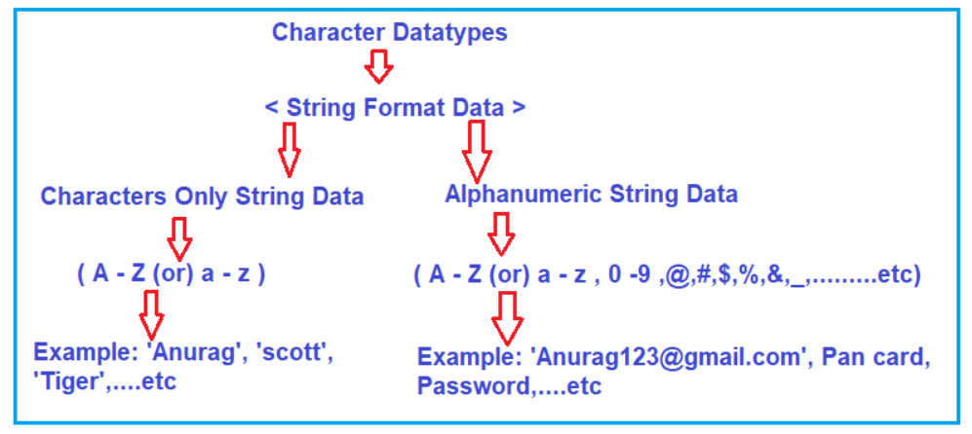

**Note:** Character Datatypes are again classified into two categories. Those are as follows.

**1. Non-Unicode Datatypes:**

Supports information which is represented only in English . These are again two types.

**i) Char(size):**

1. It is a fixed-length datatype (static).
2. For every character 1 byte of memory will be allocated
3. Maximum size of char datatype is 2000 bytes (2000 char’s).
4. Main drawback of this datatype is “memory wastage”.

Eg: StudentId CHAR(5)

* ‘a’———-> a (5 – 1 byte = wastage 4 bytes)
* ‘ab’——–> ab (5-2 = 3 bytes)
* ‘abc’—–> abc (5-3=2 bytes)
* ‘abcd’—-> abcd (5-4=1 byte)
* ‘abcde’—> abcde (5-5= 0 bytes)
* ‘abcdef’ —> error (not allowed)

**ii) Varchar2(size):**

1. It is a variable length datatype (dynamic).
2. It will store non-Unicode characters in the form of 1 char = 1 byte.
3. Maximum size of varchar2 datatype is 4000 bytes (4000 char’s).
4. It saves memory.

**Example:** **Empname char(5)**

* ‘a’———-> a (1 byte ,no memory wastage)
* ‘ab’——–> ab (2 bytes)
* ‘abc’—–> abc (3 bytes)
* ‘abcd’—-> abcd(4 bytes)
* ‘abcde’—> abcde(5 bytes)
* ‘abcdef’ —> error (not allowed)

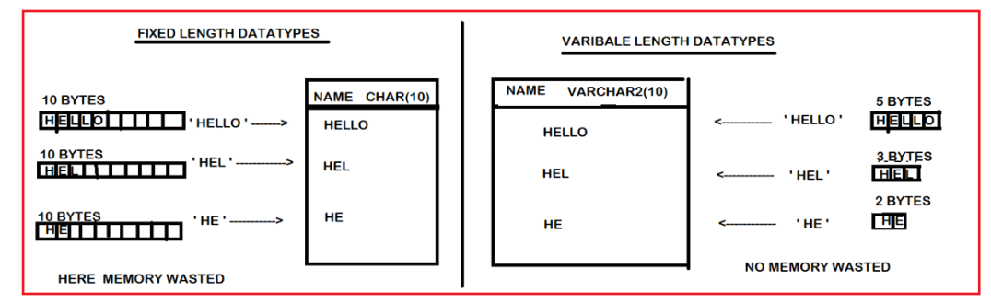

**2. Unicode datatypes:**

These data types are used for storing “globalized data/information” i.e. supporting “all national languages”. These are again classified into two types,

1. Nchar(size)
2. Nvarchar2(size)

Here,” N ” ———- National lang.

1. **Nchar(size):**
2. It is a fixed-length datatype (static).
3. It will store non-Unicode chars (all national languages) in the form of 1 char = 1 byte.
4. The maximum size of the Nchar datatype is 2000 bytes (2000 chars).
5. The main drawback of this datatype is “memory wastage”.
6. **Nvarchar2(size):**
7. It is a variable-length datatype (dynamic).
8. It will store non-Unicode characters (all national languages) in the form of 1 char = 1 byte.
9. The maximum size of the Nvarchar2 datatype is 4000 bytes (4000 chars).
10. The main advantage is “save memory”.

**3) Long Datatype in Oracle:**

1. It is a Variable length datatype(dynamic)
2. It will Store both non-Unicode & Unicode char’s in the form of 1 char = 1 byte
3. Max size of the Long Data type is 2 GB.
4. A table can have only one long data type column.

##### ****4) Date Datatypes in Oracle:****

It is used for storing the date & time information of a particular day.

###### ****i) Date:****

date providing date value is mandatory & providing time value is optional. When the user has not provided the input for time , then the oracle database server will take time by default ’12:00:00′ am / ’00:00:00’am .

**Default date & time format of Oracle database.**

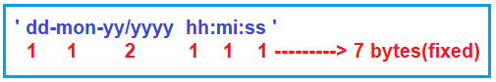

It occupied 7 bytes of memory (fixed memory)

They should be provided in single quotes.

###### ****ii) Timestamp:****

Storing date & time information including ‘milliseconds’. Default format of timestamp datatype is ‘dd-mon-yyyy / yy hh: mi: ss.ms’. It occupied 11 bytes of memory (fixed memory).

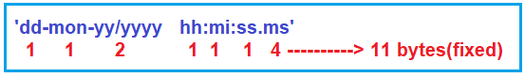

They should be provided in single quotes.

**Raw & Long Raw Datatypes in Oracle:**

These data types are used to store image/audio /video files in the form of 01001010100010101 binary formats.

1. Raw ———> 2000 bytes
2. Long Raw —> 2gb

These data types are also called “binary datatypes”.

##### ****LOB Datatypes in Oracle:****

LOB stands for Large Objects.

###### ****i) BLOB:****

BLOB stands for Binary Large Object and this Data Type is used for storing image/audio /video files in the form 010010101001 binary format. The maximum size is 128 TB.

###### ****ii) CLOB:****

CLOB stands for character large object and this Data Type is used for storing non-Unicode characters. The maximum size is 128 TB.

###### ****iii) NCLOB:****

NCLOB stands for National characters large object and this data type is used for storing Unicode characters. The maximum size is 128 TB.

